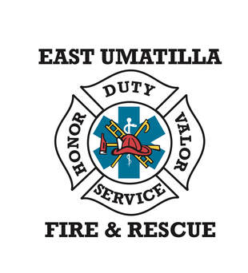
EAST UMATILLA FIRE & RESCUE
103 W. Main Street Weston, OR 97886 (soon to be 422 West Mill street)
CHIEF’S REPORT for September, 2024
EUFR calls for Service in August 2024 = 46
EMS = 32 Fire = 6 MVA = 3 False A. = 0 Mutual Aid = 3 Canc enroute = 2 Lines down = 2 Good Intent = 1
1) The new station. We’ve moved in. We now have three on duty 24/7. A mixture of medics and firefighters. (Very soon, they will all be certified Firefighter 1s. This is an enormous upgrade in the service we provide.) There are many details being worked on: door locks, phones, fax machines, bay doors and I could go on for a while. We have yet to receive the final “pay application” from McCormack. We are forecasting spending an amount of our normal operating budget. We knew this was coming last year and prepared by putting a larger than normal amount of funds in the Contingency section of our budget. However, as we are being very careful with our spending, the incidentals are beginning to add up.
3) The Ribbon Cutting is on October 8 at 11:00 AM. We are planning for a small ceremony, followed by the opening of the station for self-guided tours. We will serve a BBQ lunch with burgers and hot dogs, salad and chips. We will make media notifications as well as the mayors in the towns our district serves. This will be a day of EUFR celebration and accomplishment we hope to share with you.
4) The Fuels Reduction and Structure Assessment program continues. ODF has moved the fire threat to high. There are Power Driven Machine restrictions.
5) EUFR responded to a single family dwelling structure fire in Adams on 9-9-2024. It was a stubborn burning fire that quickly involved the roof system. There were many void spaces where fire had to be found; and revealed. We received mutual aid from the Tribal Fire Department and Pendleton Fire and Ambulance. We were there for many hours exposing and cooling hot spots.

